**COVID-19 Therapeutic Antibody Tracker: a Global Database of Antibody Therapeutics for the Prevention and Treatment of COVID-19**

**Abstract (**in 250 words**)**

Facing COVID-19 pandemic as a global healthcare crisis, scientists worldwide are collaborating to develop prophylactic and therapeutic interventions against COVID-19.  Antibody therapeutics hold enormous promise for treatment of COVID-19. Chinese Antibody Society, in collaboration with [The](https://www.antibodysociety.org/) [Antibody Society](https://www.antibodysociety.org/), has been developing the “COVID-19 Therapeutic Antibody Tracker” (“Tracker”) to track the global antibody-based COVID-19 programs in preclinical and clinical development. All the data were collected from the public domain and cross-verified by volunteers.

The tracker is integrated into Chinese Antibody Society’s website using WordPress system. The data is regularly updated and proofread. Exploratory data analysis and visualization has also been conducted to present the latest trends of COVID-19 antibody development. We categorized the data mainly by their targets, formats, status of development, developers and countries. Among the programs and molecules, more than 50% of the COVID-19 antibody candidates are targeting the SARS-COV-2 Spike protein (S protein) and in the antibody format. Most of these virus-specific therapeutic antibodies are in discovery or preclinical stage. USA and China are the two leading countries in developing COVID-19 antibody therapeutics. Most of the current COVID-19 antibody therapeutic candidates in clinical trials are repurposing drugs aimed at other targets other than the virus-specific protein.

**Statement of Significance (**in 50 words**)**

Chinese Antibody Society, in collaboration with [The](https://www.antibodysociety.org/)[Antibody Society](https://www.antibodysociety.org/)**,** developedthe “COVID-19 Therapeutic Antibody Tracker” (“Tracker”) to provide a global database for scientists and the general public to track ongoing preclinical and clinical development of antibody-based therapeutics for prevention and treatment of COVID-19 during the pandemic in a timely manner.

**Introduction**

The recent outbreak of COVID-19 has emerged from a public health emergency to a major global pandemic. As the COVID-19 pandemic is the global healthcare crisis, scientists worldwide are collaborating to develop prophylactic and therapeutic interventions against COVID-19.  Antibody therapeutics hold enormous promise for treatment of COVID-19. To join the global endeavor against the pandemic with our expertise, Chinese Antibody Society, in collaboration with [The](https://www.antibodysociety.org/)[Antibody Society](https://www.antibodysociety.org/)**,** developedthe “COVID-19 Therapeutic Antibody Tracker” (“Tracker”) to track the worldwide antibody-based COVID-19 therapeutics in preclinical and clinical development.

**Establishment of the “Tracker”**

**The data of the “Tracker” is being collected from resources of public domain by volunteers from** [**The**](https://www.antibodysociety.org/)[**Antibody Society**](https://www.antibodysociety.org/) **and the Chinese Antibody Societies. As the workflow shown in Figure 1, as a major approach, the data was collected and summarized from literatures, preprints, search engines, company websites, biotech newsfeed, social media, government databases, etc. In another way, when available, automatic process is being developed and integrated to retrieve data from online databases such as ClinicalTrials.gov by command-line tools. Therapeutics programs based on non-antibody proteins with the similar mechanisms of actions as antibodies, such as recombinant ACE2 protein and Fc-fusion proteins, are also included. Unrelated information such as** diagnostic antibodies, polyclonal plasma from convalescent patients, and clinical trials without specific indications to COVID-19 patients in experimental design, were excluded. For quality evaluation, all the final data included in the “Tracker” were cross-verified manually by at least two independent volunteers. We categorized the data as: target, format, status of development, developer and country, as well as references.

To build the “Tracker”, the data table containing filtered results was uploaded to the website of Chinese Antibody Society, which was build using WordPress system. We used WPDatatable Plugin to integrate the data table from backend to front end of the webpage. On our “Tracker” website, the whole dataset was displayed as an interactive table, and grouped by the categories we defined above. We also performed data analysis and visualization based on the key features of the collected antibody therapeutic information that is most relevant to the scientific community and general public. These include the numbers of therapeutic targets, formats, and program development status of the antibody therapeutics. In addition, we plotted the distribution of program development status by country to track the progress of COVID-19 antibody therapeutics programs in different countries.

Figure 1.Process of building the COVID-19 Therapeutic Antibody Tracker

**Data analysis and visualization**

To further elaborate the function of the “Tracker”, we performed data visualization and analysis based on the key features of the collected antibody therapeutic information. As shown in **Figure 2**, the “Tracker” is currently tracking 147 programs and molecules for COVID-19 interventions from discovery to clinical development. Among the programs and molecules, 83 are targeting the SARS-COV-2 S protein as antiviral interventions by blocking virus entry. Sixty of the programs and molecules were developed to target the host immune system for other indications and now repurposed to treat COVID-19, by potentially alleviating COVID-19-related symptoms such as cytokine storm and inflammation instead of directly killing the viruses (Figure 2A). As shown in Figure 2B, over 80% of these therapeutics are in conventional antibody format, and the rest are in bi- or tri-specific antibody, single-domain antibody, polyclonal antibodies, fusion protein, and other (e.g. DARPin, mRNA-encoding mAb, radiotherapeutics) formats.

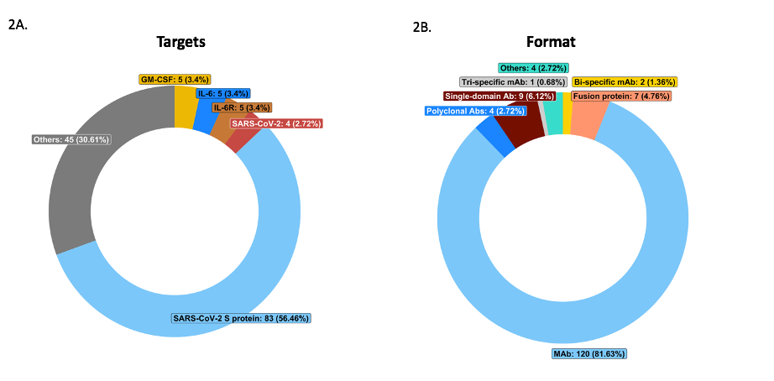

Figure 2. Analysis of targets and formats of the therapeutics under development for COVID-19. (A) Distribution of therapeutic targets of therapeutic antibodies under development for COVID-19. (B). Distribution of the formats for therapeutics under development for Covid-19. The number of programs for each target and format are shown, followed by the proportion to the total number of all programs in paraphrase. Only the top five targets and formats by amounts are shown, the rest were populated in “Others” (see inlet tables for details).

Among the programs and molecules we are tracking, over 60% are in discovery and preclinical stages (Figure 3A), including the majority of the ones that specifically target the SARS-COV-2 virus S protein and. blocking the virus entry. Four antibody candidates targeting the SARS-COV-2 S protein have entered clinical stages, including REGN-COV2 (Renegeron, three clinical trials in Phase 1/2/3), LY-CoV555 (Eli Lilly/AbCellela, two clinical trials in Phase 1 and 2), JS016 (Eli Lilly/Junshi, clinical trial in Phase 1), and TY027 (Tychan, clinical trial in Phase 1) (see detail information in “Tracker”). Other than these four programs, most of COVID-19 antibody therapeutic candidates in clinical trials are repurposing drugs aimed at other targets rather than the S protein. Levilimab, which was develop by BIOCAD to targets IL-6R, has been registered in Russia for the inhibition of cytokine storm caused by coronavirus infection. USA and China are the two leading countries in developing COVID-19 antibody therapeutics, followed by Canada, Germany, South Korea, UK, and France (Figure 3B).

Figure 3. Development status of COVID-19 therapeutic antibodies. (A). Distribution of program development status for COVID-19 therapeutic antibodies in development globally. The status is categorized into discovery, preclinical, clinical pending, phase I, phase I/II, phase I/II/III, phase II, phase II/III, phase III and approved. (B). Stacked bar chart showing the status of antibody therapeutics development by country. The status of clinical trials are color-coded from dark blue (the earliest phase) to dark red (the latest phase). For therapeutic candidates being developed across multiple countries, each participating country has been counted separately in this chart.

**Conclusion and Perspectives**

While we are developing the “Tracker” and writing this review, the COVID-19 pandemic is evolving globally and resulting in unprecedented impacts on the worldwide healthcare, research and economy. COVID-19 requires urgent development of effective treatment. To help addressing the emergent needs, the “Tracker” provides a useful reference for researchers and public society to track current progress of drug development for COVID-19.

Acknowledgment

References